## **Interface Design**

User Interface (UI) Design focuses on anticipating what users might need to do and ensuring that the interface has elements that are easy to access, understand, and use to facilitate those actions. UI brings together concepts from [interaction design](https://www.usability.gov/what-and-why/interaction-design.html), [visual design](https://www.usability.gov/what-and-why/visual-design.html), and [information architecture](https://www.usability.gov/what-and-why/information-architecture.html).

Interface elements include but are not limited to:

* Input Controls: buttons, text fields, checkboxes, radio buttons, dropdown lists, list boxes, toggles, date field
* Navigational Components: breadcrumb, slider, search field, pagination, slider, tags, icons
* Informational Components: tooltips, icons, progress bar, notifications, message boxes, modal windows

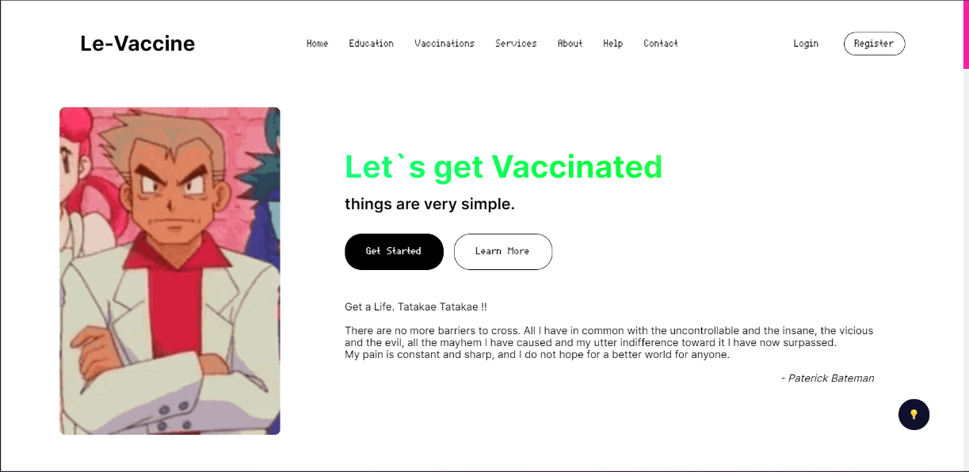

*Figure 4.1*

*Figure 4.4*

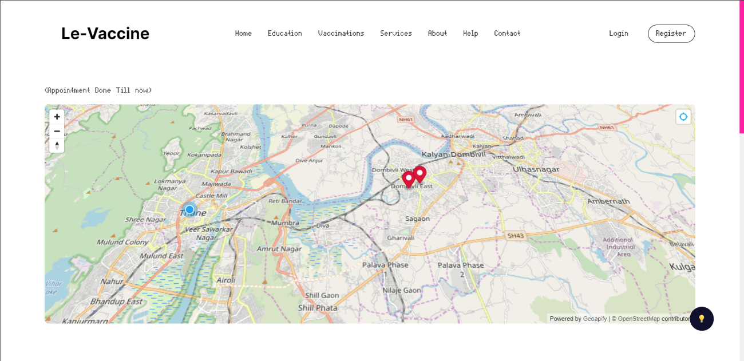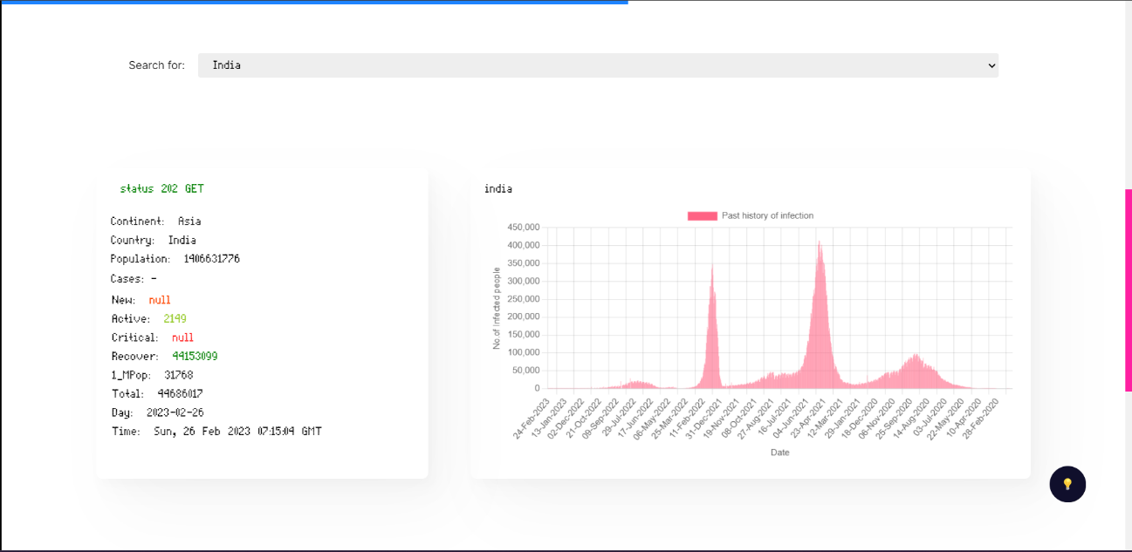

*Figure 4.3*

*Figure 4.2*

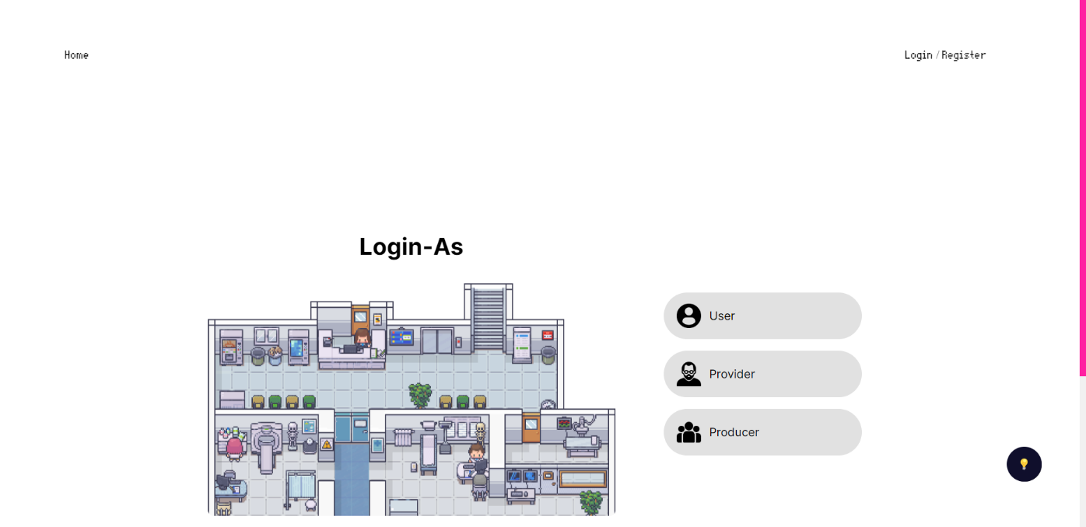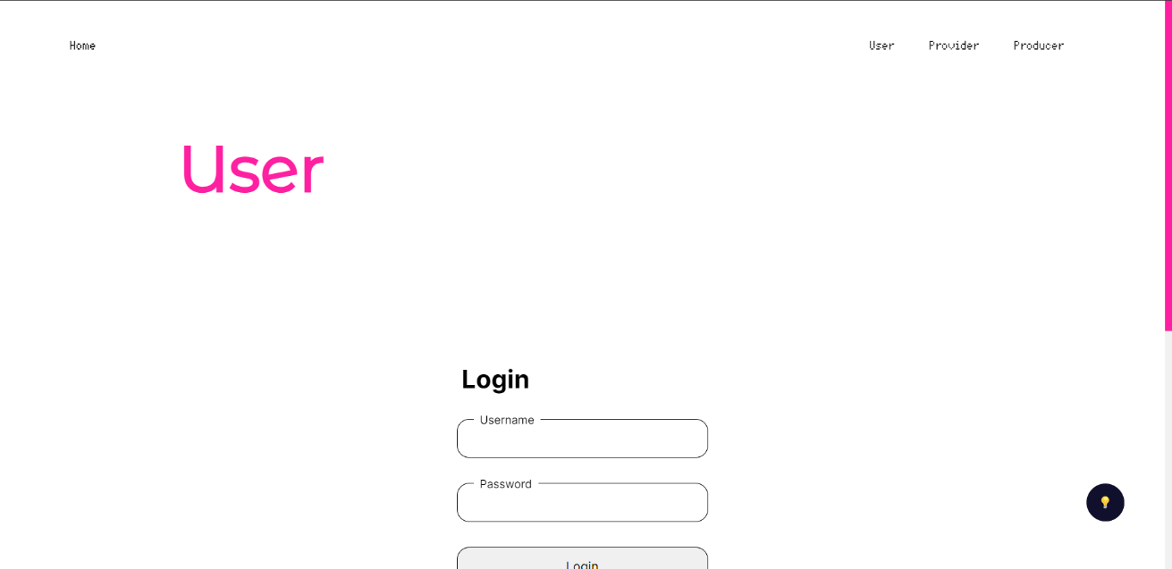

*Figure 4.5*

*Figure 4.4*

*Figure 4.3*

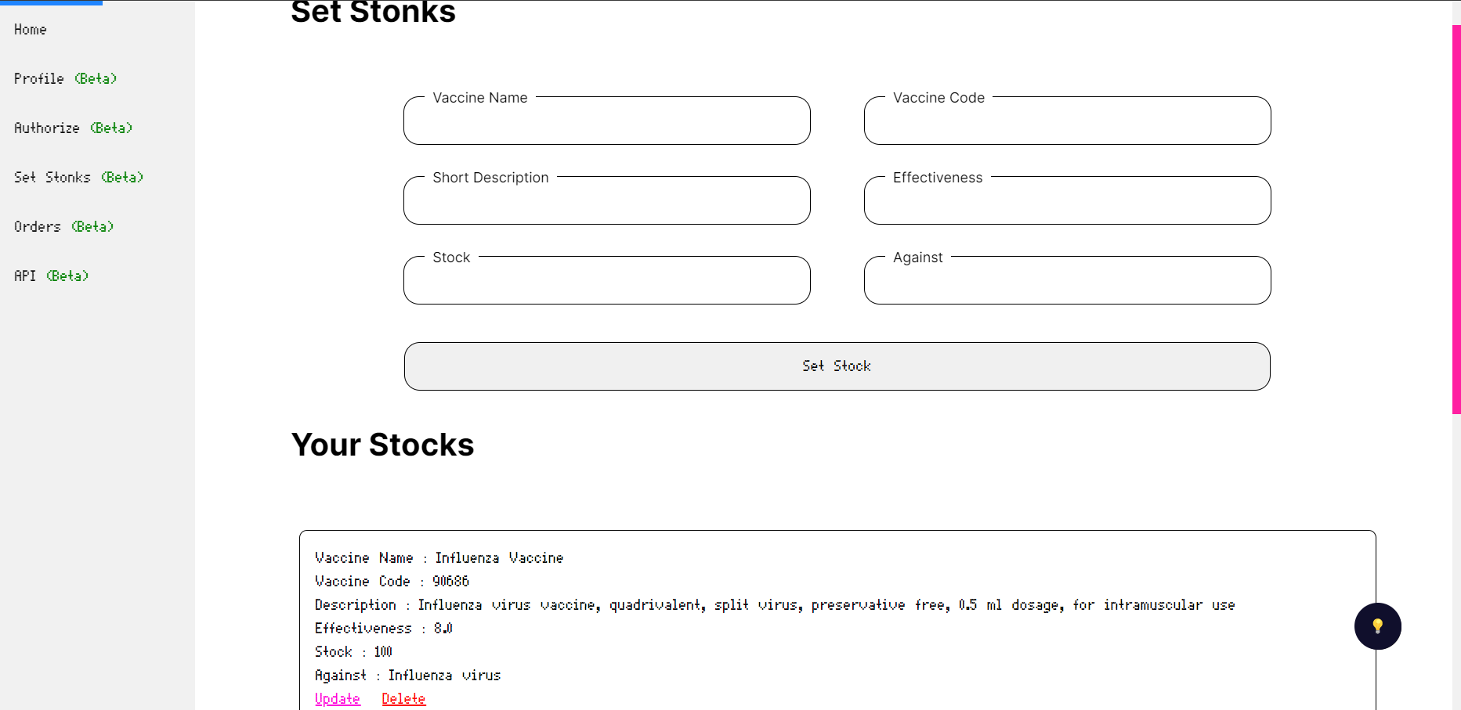

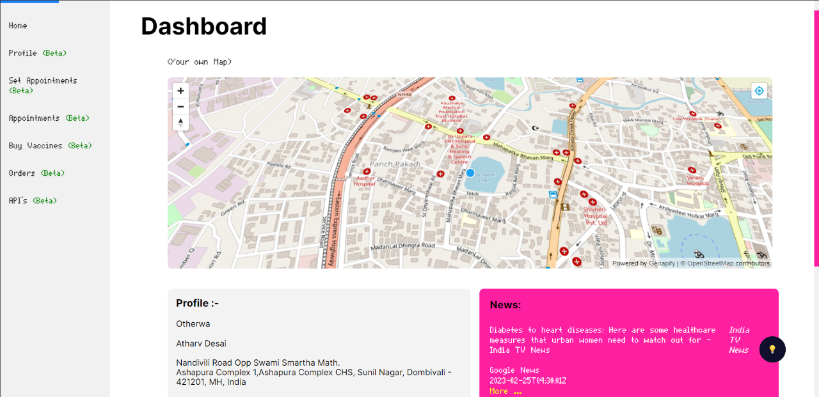

*Figure 4.7*

*Figure 4.6*

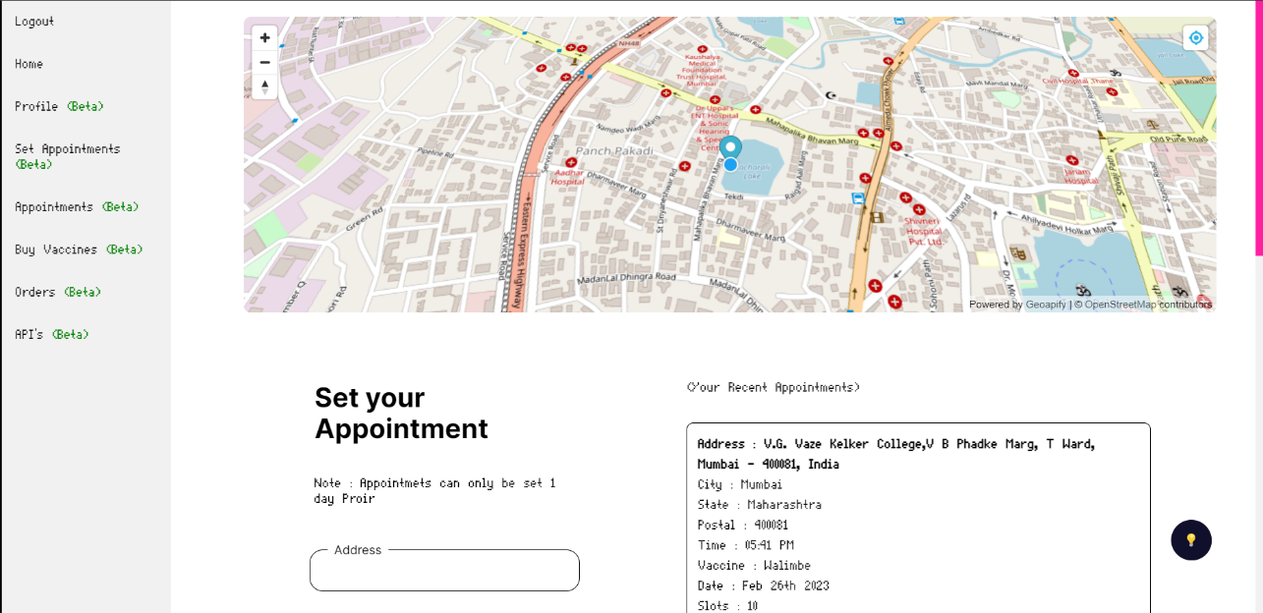

*Figure 4.8*

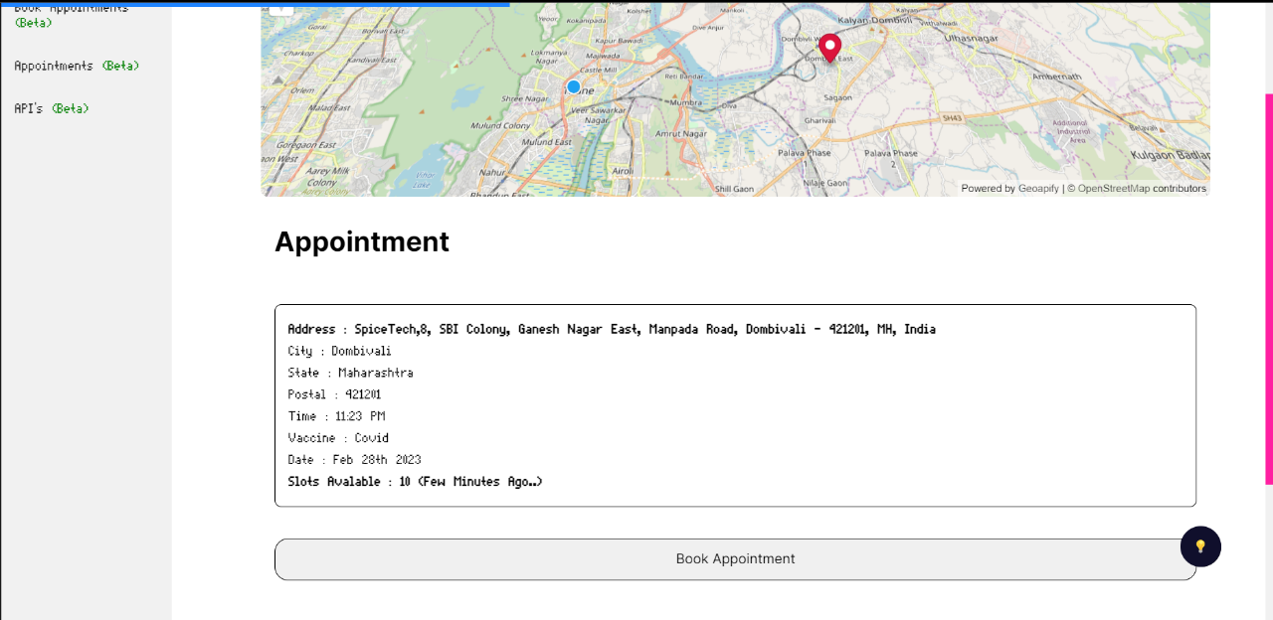

*Figure 4.9*

*Figure 4.8*

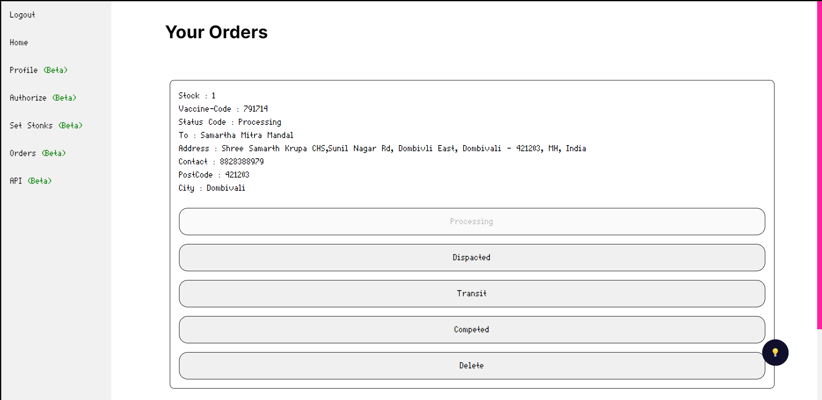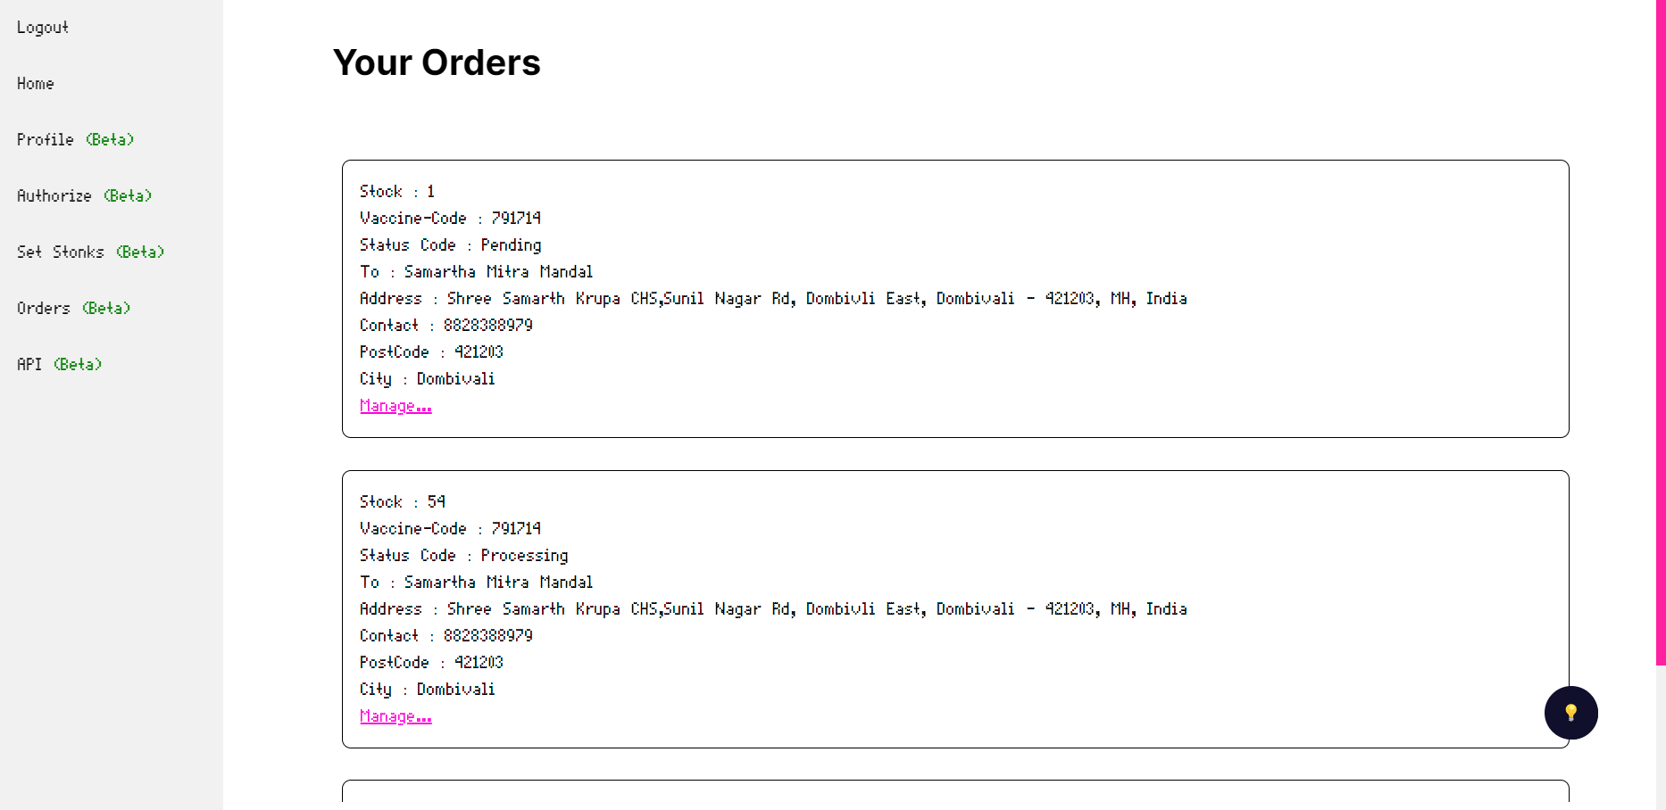

*Figure 4.11*

*Figure 4.10*

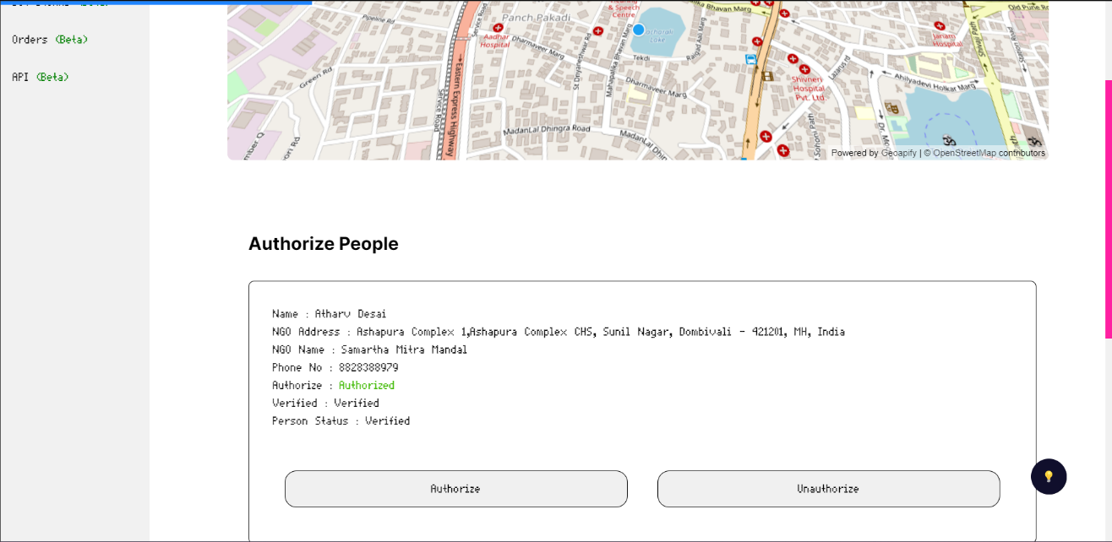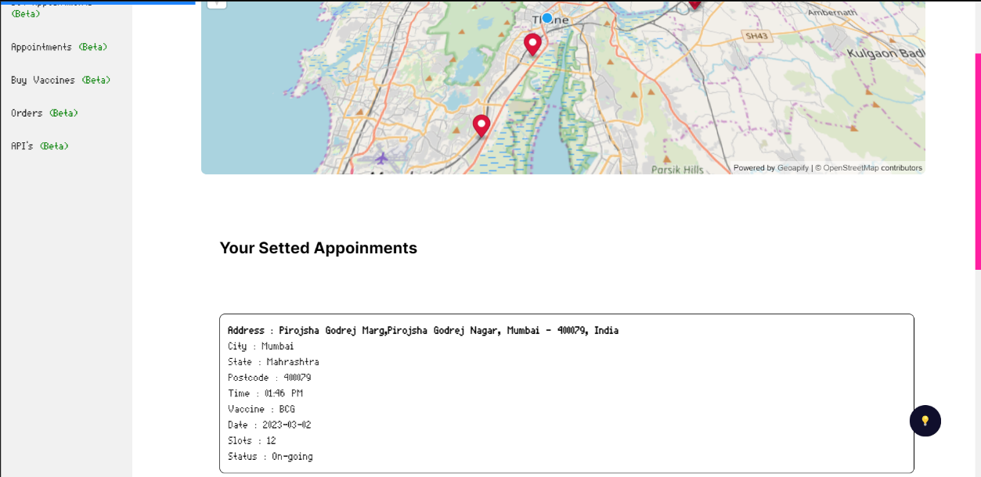

*Figure 4.13*

*Figure 4.12*

## 4.2 Test Cases

|  |  |  |  |  |  |
| --- | --- | --- | --- | --- | --- |
| ID | Test Case Description | Test Case Data | Expected Result | Actual Result | Remark |
| User Test Cases | | | | | |
| 0 | Login for user | Username: Otherwa  Password: admin | Should get redirected to the dashboard | Gets redirected | Pass |
| 2 | Register for User | Username: Otherwa  Password: admin  Name: Atharv Ankush Desai, Age 20,gender male,  Adhar no 12121243445. pincode 42120,phone-no 8828388979,email atharvdesai2002@gmail.com | Error due to Adhar no | As Expected | Pass |
| 3 | Book Appointments | Appointment Name XXY  Appointment Time 13:00 – 14:00  Date: 21/09/222  (On Book Button Click) | The appointment Should be booked | As Expected | Fail |
| 4 | Update Profile for user | Username: Otherwa  Password: admin  Name: Atharv Ankush Desai, Age 20,gender male,  Adhar no 2023023023. pincode 42120,phone-no 8828388979,email atharvdesai2002@gmail.com | User Profile Updated | As expected | Pass |
| 5 | Register for User | Username: Otherwa  Password: admin  Name: Atharv Ankush Desai, Age 20,gender male,  Adhar no 1212232pincode 421201,phone-no 882838899,email atharvdesai2002@gmail.com | Error due to Phone number | As Expected | Pass |
| Provider Test Cases : | | | | | |
| 6 | Set Appointments | Appointment Name : XYZ  Appointment Location : Nalasopara/202,22e  Appointment Timming : 13:00 – 14:00  Appointment Date : 24/09/22 | Appointemnt should be setted up | As Expected | Pass |
| 7 | Buy Vaccine | On certain vaccine buy confirm order button click and checkout | Order should be placed | Error in Buying Required Amount | Fail |
| 8 | Profile Update for provider | Username: Otherwa  Password: admin  Name: Atharv Ankush Desai, Age 20,gender male,  Adhar no 1212232pincode 421201,phone-no 882838899,email atharvdesai2002@gmail.com  NGO : Atmaram NGO | Profile Updated | As Expected | Pass |
| 9 | Profile Update for provider | Username: Otherwa  Password: admin  Name: Atharv Ankush Desai, Age 20,gender male,  Adhar no 1212232pincode 421201,phone-no 882838899,email atharvdesai2002@gmail.com  NGO : | Profile Not Updated  NGO Field Blank | As Expected | Pass |
| 10 | Update profile for provider | Username: Otherwa  Password: admin  Name: Atharv Ankush Desai, Age 20,gender male,  Adhar no 1212232pincode 421201,phone-no 8828388979,email atharvdesai2002gmail | Error due to invalid email | As Expected | Pass |
| 11 | Set Appointments | Appointment Name : XYZ  Appointment Location : Nalasopara /202,22e  Appointment Timming : 13:00 – 14:00  Appointment Date : | Error due to no date specified | As Expected | Pass |
| 12 | Set Appointments | Appointment Name : XYZ  Appointment Location : Nalasopara /202,22e  Appointment Timming : 13:00 –  Appointment Date : 20.09.22 | Error due to no end time specified | As Expected | Pass |
| Provider Test Cases | | | | | |
| 13 | Process Orders | On button Click of delete order status order should be deleted | Order Should get deleted | As Expected | Pass |
| 14 | Process Orders | On button Click of Update order status order should be updated | Order Should get Updated | As Expected | Pass |
| 15 | Update Vaccine Stonks | Vaccine Name : BCG  Vaccine Code : 2033  Description: wfwddssdsd  Quantity:203 | Vaccine stocks not Updated due to faulty description | As Expected | Pass |
| 16 | Profile Update For Producer | Username: Otherwa  Password: admin  Name: Atharv Ankush Desai, Age 20,gender male,  Adhar no 1212232pincode 421201,phone-no 8828388979,email [atharvdesai2002@gmail.com](mailto:atharvdesai2002@gmail.com)  Company Name : Le-Vaccine  Company Address : C/202 Shree Samartha Krupa | Should not get updated Successfully  Not valid Company Name | As Expected | Pass |
| 17 | Profile Update For Producer | Username: Otherwa  Password: admin  Name: Atharv Ankush Desai, Age 20,gender male,  Adhar no 1212232pincode 421201,phone-no 8828388979,email [atharvdesai2002@gmail.com](mailto:atharvdesai2002@gmail.com) | Should get updated Successfully | As Expected | Pass |
| 18 | Process Orders | On the button Click of Update order status order should be updated | Order Should get Updated | As Expected | Pass |
| 19 | View Order Status | On button click of view status | Order status should be shown | As Expected | Pass |
| 20 | Update Vaccine Stonks | Vaccine Name: BCG  Vaccine Code: 2033  Description: For Immunity etc,  Quantity:203 | Vaccine stocks Updated | As Expected | Pass |
| 21 | Update Vaccine Stonks | Vaccine Name: BCG  Vaccine Code: 2033  Description: For Immunity etc,  Quantity:0 | Vaccine stocks Updated | As Expected | Pass |
| 22 | Update Vaccine Stonks | Vaccine Name: BCG  Vaccine Code: 2033  Description: For Immunity etc,  Quantity: | Vaccine stocks are not Updated | As Expected | Pass |
| 23 | Profile Update For Producer | Username: Otherwa1  Password: admin  Name: Atharv Ankush Desai, Age 20,gender male,  Adhar no 1212232pincode 421201,phone-no 8828388979,email [atharvdesai2002@gmail.com](mailto:atharvdesai2002@gmail.com)  Company Name: Bhartia Biotech  Company Address: C/202 Shree Samartha Krupa | The username is already taken error | As Expected | Pass |
| 24 | Profile Update For Producer | Username: Otherwa  Password: admin  Name: Atharv Ankush Desai, Age 20,gender male,  Adhar no 1212232pincode 421201,phone-no 8828388979,email [atharvdesai2002@gmail.com](mailto:atharvdesai2002@gmail.com) : | Should not get updated Successfully | As Expected | Pass |
| 25 | Profile Update For Producer | Username: Otherwa  Password: admin  Name: Atharv Ankush Desai, Age 20,gender male,  Adhar no 1212232pincode 421201,phone-no 8828388979,email [atharvdesai2002@gmail.com](mailto:atharvdesai2002@gmail.com) | Should not get updated Successfully | As Expected | Pass |

*Tabl,e 4.1*

## 5.1 Implementation Approaches

The Vaccine Management System (Le-Vaccine) project was created utilising Extreme Programming Concepts (XP), which is intended to increase software quality and responsiveness to client needs. The extreme programming approach suggests scaling up the best methods that have previously performed successfully in programme development initiatives to extreme levels. Extreme Programming (XP) is a software development process that emphasises high-quality product delivery through frequent and continuous feedback, collaboration, and adaptability. With an emphasis on rapid, iterative development and deployment, XP promotes a close working relationship between the development team, the client, and stakeholders. If the user requirements change at any time, the appropriate component can be rebuilt, reimplemented, and tested again.

The requirements were analysed, and the project was promptly put into action by developing the necessary user interfaces. The interfaces were designed and built utilising Microsoft Studio Code and a database provided by Mongo Atlas Service. The frontend of the project was coded in EJS with CSS for style and Js for adding functionalities, and the backend was coded in REST API routes using Express Library. The project was broken down into modules. These modules were built one at a time, and once each one was finished, unit testing was performed on it. The module was included into the main project as soon as it met its requirements. Following integration, each whole module capability was tested, which can also be referred to as integration testing. After adding all the modules to the main project, the final testing was performed to check whether the system was performing properly or not.

The validations were used wherever required. The system was made thinking about all the problems that it could face and thereby proper measures were taken to make sure that the system does not get affected by them. The final product would be delivered when it satisfies all the requirements and functionalities

## 5.2 Coding Details and Coding Efficiency

### 5.2.1 Efficency:

Booking Appointments:

* View All Appointments Route.

Router.get('/user/dash/bookappo', auth, livedata, async (req, res) => {

await connect()

const cookie = req.cookies.jwt

console.log(moment(new Date()).format('YYYY-MM-DD'))

console.log(moment(new Date()).format('hh:mm A'))

// nearby pincode match

let pincode = Number(req.user.detail.postcode)

// match nearby pincodes

pins = [pincode - 2, pincode - 1, pincode, pincode + 1, pincode + 2]

console.log(pins)

console.log(

moment(new Date()).format()

)

appo.find({ 'status': false, 'postcode': { $in: pins }, 'details.date': { $gt: moment(new Date()).format('YYYY-MM-DD'), } }, (err, result) => {

if (err) console.log(err)

console.log(result)

const pos = result.map(position);

result.map(time);

function time(item) {

// change 24.00 to XX.XX AM/PM moment library

item.details.time = moment(item.details.time).format('hh:mm A');

item.details.date = moment(item.details.date).format("MMM Do YYYY");

// console.log(item.details.time)

}

// console.log(pos)

function position(item) {

return (item.details.position);

}

res.render('account/user/bookappo', {

data: req.user,

token: cookie,

appos: result,

appos_: pos,

csrf_token: req.csrfToken()

});

})

})

* Book Appointements Route:

Router.post('/dash/bookappo/:id', auth, livedata, async (req, res) => {

console.log("heer")

const id = req.params.id

console.log(id.toString())

console.log(req.user._id.toString())

user.bookappo(req, res, id, req.user._id)

})

* Book Appoinment Method:

userSchema.prototype.bookappo = async (req, res, appoid, userid) => {

// sleep

await connect()

async function awaitUpdate() {

try {

appos.findById(appoid).then((doc) => {

// awaiting resposne

if (doc.details.slots > 0 && Boolean(doc.status) == false) {

appos.findByIdAndUpdate(appoid, { $inc: { 'details.slots': '-1' } }, (err, results) => {

if (err) console.log(err)

console.log(results)

const appo = new appolist({

appoid: appoid,

userid: userid,

date: new Date()

})

appo.save((err, result) => {

if (err) console.error(err)

console.log(result)

// req.flash('msg', "Appointment Booked")

res.json({ status: '200' })

user_bookappo(req.user.email, req.user.username, results)

return results

})

})

} else {

// req.flash('err', "Appointment Was Not Booked")

res.json({ status: '404' })

}

})

}

catch (err) {

handleError(err);

}

}

let appoupdate = await awaitUpdate()

console.log(appoupdate + " asdas")

}

The Serializability Issue For Booking Appointments Was Fixed By Introducing Random 1000 – 5000 Ms Delay Along with An Async Promise Call-back which allows The Express Logic Layer to Read/Write the Correct Amount of Slots Remaining For the Appointments

Similar Approach is Done For Booking Vaccine Orders And Order Status

More Over a Map is Integrated Using Geoapify and Maplibre API which Provide Geospatial Data For a Set Of Co-ordinates Dragged by the Provider For Setting Appointments ,User Locations etc.

Buy Vaccine:

* Route

// stop appointments

Router.put('/dash/buyvaccines/buy', pauth, livepdata, async (req, res) => {

console.log(req.body)

// console.log(req.user)

//stop appointemts

provider.buyvaccine(req, res, req.body.prodid, req.body.proid, req.body.stonkid, req.user.detail, req.body.vaccinecode, 'Pending', req.body.stock, req.body.email)

})

* Method

providerSchema.prototype.buyvaccine = async (req, res, prodid, proid, stonkid, details, vac, status, stock, email) => {

stonks.findById(stonkid, (err, data) => {

if (err) { console.log(err) }

console.log(data)

if (data.stocks > 0) {

stonks.findByIdAndUpdate(stonkid, { $inc: { stocks: -Number(stock) } }).then(() => {

new orders({

prodid: prodid,

proid: proid,

stonkid: stonkid,

details: details,

vaccinecode: vac,

status: status,

stock: stock,

date: new Date()

}).save((err, result) => {

if (err) { console.log(err) }

producerSchema.findById(prodid).then(data => {

sendrecept(email, result, data)

res.send(result)

})

})

})

} else {

res.send('no')

}

})

The Buying Module uses High R/W of the MongoDb to Ensure each specific document is up to date

## 5.3 Testing Approach

The Testing Approach for the project was solely based on the reliability of the components implemented through Several Testing Phases to ensure the quality of the system is up to the requirements specified.

### 5.3.1 Unit Testing

These Tests are designed to ensure that each unit performs as expected and produces the correct outputs for various inputs or scenarios

Test Cases:

|  |  |  |  |  |  |
| --- | --- | --- | --- | --- | --- |
| ID | Test Case Description | Test Case Data | Expected Result | Actual Result | Remark |
| 1 | User Login | Username : Otherwa  Password:Gokussj@12345 | Should Redirect to Dashboard | As Expected | Pass |
| 2 | User Login | Username : Otherwa  Password: | Should Not Redirect to Dashboard and Show Error | As Expected | Pass |
| 3 | User Login | Username : Password:Gokussj@12345 | Should Not Redirect to Dashboard and Show Error | As Expected | Pass |
| 4 | User Login | Username :  Password: | Should Not Redirect to Dashboard and Show Error | As Expected | Pass |

Table 5.1 User Login

|  |  |  |  |  |  |
| --- | --- | --- | --- | --- | --- |
| ID | Test Case Description | Test Case Data | Expected Result | Actual Result | Remark |
| 5 | User Login | Username : Otherwa  Password:Gokussj@12345 | Should Redirect to Dashboard | As Expected | Pass |
| 6 | User Login | Username : Otherwa  Password: | Should Not Redirect to Dashboard and Show Error | As Expected | Pass |
| 7 | User Login | Username : Password:Gokussj@12345 | Should Not Redirect to Dashboard and Show Error | As Expected | Pass |
| 8 | User Login | Username :  Password: | Should Not Redirect to Dashboard and Show Error | As Expected | Pass |

Table 5.2 Provider Login

|  |  |  |  |  |  |
| --- | --- | --- | --- | --- | --- |
| ID | Test Case Description | Test Case Data | Expected Result | Actual Result | Remark |
| 9 | User Login | Username : Otherwa  Password:Gokussj@12345 | Should Redirect to Dashboard | As Expected | Pass |
| 10 | User Login | Username : Otherwa  Password: | Should Not Redirect to Dashboard and Show Error | As Expected | Pass |
| 11 | User Login | Username : Password:Gokussj@12345 | Should Not Redirect to Dashboard and Show Error | As Expected | Pass |
| 12 | User Login | Username :  Password: | Should Not Redirect to Dashboard and Show Error | As Expected | Pass |

Table 5.3 Producer Login

|  |  |  |  |  |  |
| --- | --- | --- | --- | --- | --- |
| ID | Test Case Description | Test Case Data | Expected Result | Actual Result | Remark |
| 13 | User Register | Username : Otherwa  Email:atharvdessai2002@gmail.com  Password:Gokussj@12345 | Should Get Registered | As Expected | Pass |
| 14 | User Register | Username : Otherwa  Email:atharvdessai2002@gmail.co  Password:Gokussj@12345 | Should Not Get Registered And validation | As Expected | Pass |
| 15 | User Register | Username:Other  Email:atharvdessai2002@gmail.com  Password:123213 | Should Not Get Registered | As Expected | Pass |
| 16 | User Register | Username Otherwa  Email:  Password:Gokussj@12345 | Should Not Redirect to Dashboard and Show Error | As Expected | Pass |

Table 5.3 User Register

|  |  |  |  |  |  |
| --- | --- | --- | --- | --- | --- |
| ID | Test Case Description | Test Case Data | Expected Result | Actual Result | Remark |
| 17 | Provider  Register | Username : Otherwa  Email:atharvdessai2002@gmail.com  Password:Gokussj@12345 | Should Get Registered | As Expected | Pass |
| 18 | Provider  Register | Username : Otherwa  Email:atharvdessai2002@gmail.co  Password:Gokussj@12345 | Should Not Get Registered And validation | As Expected | Pass |
| 19 | Provider  Register | Username:Other  Email:atharvdessai2002@gmail.com  Password:123213 | Should Not Get Registered | As Expected | Pass |
| 20 | Provider  Register | Username Otherwa  Email:  Password:Gokussj@12345 | Should Not Redirect to Dashboard and Show Error | As Expected | Pass |

Table 5.5 Provider Register

|  |  |  |  |  |  |
| --- | --- | --- | --- | --- | --- |
| ID | Test Case Description | Test Case Data | Expected Result | Actual Result | Remark |
| 21 | Provider  Register | Username : Otherwa  Email:atharvdessai2002@gmail.com  Password:Gokussj@12345 | Should Get Registered | As Expected | Pass |
| 22 | Provider  Register | Username : Otherwa  Email:atharvdessai2002@gmail.co  Password:Gokussj@12345 | Should Not Get Registered And validation | As Expected | Pass |
| 23 | Provider  Register | Username:Other  Email:atharvdessai2002@gmail.com  Password:123213 | Should Not Get Registered | As Expected | Pass |
| 24 | Provider  Register | Username Otherwa  Email:  Password:Gokussj@12345 | Should Not Redirect to Dashboard and Show Error | As Expected | Pass |

Table 5.6 Provider Register

Table 5.7 User Update Profile

|  |  |  |  |  |  |
| --- | --- | --- | --- | --- | --- |
| ID | Test Case Description | Test Case Data | Expected Result | Actual Result | Remark |
| 25 | User Profile | FirstName:Atharv  LastName:Desai  Address:C/202  Age:20  Phone:8828388979  City:Dombivili  Region:Maharstra  Gender:Male  PostCode:421201 | Should Get Updated | As Expected | Pass |
| 26 | User Profile | FirstName:Atharv  LastName:Desai  Address:C/202  Age:20  Phone:  City:Dombivili  Region:Maharstra  Gender:Male  PostCode:421201 | Should Not Get Updated | As Expected | Pass |

|  |  |  |  |  |  |
| --- | --- | --- | --- | --- | --- |
| ID | Test Case Description | Test Case Data | Expected Result | Actual Result | Remark |
| 27 | Provider Profile | FirstName:Atharv  LastName:Desai  Address:C/202  Age:20  Phone: 8828388979  City:Dombivili  Region:Maharstra  Gender:Male  PostCode:421201  NGO Address : C/202 Mandal  NGO Name : mitra Mandal | Should Get Updated | As Expected | Pass |
| 28 | Provider Profile | FirstName:Atharv  LastName:Desai  Address:C/202  Age:20  Phone:  City:Dombivili  Region:Maharstra  Gender:Male  PostCode:421201  NGO Address : C/202 Mandal  NGO Name : mitra Mandal | Should Not Get Updated | As Expected | Pass |

Table 5.8 Provider Update Profile

|  |  |  |  |  |  |
| --- | --- | --- | --- | --- | --- |
| ID | Test Case Description | Test Case Data | Expected Result | Actual Result | Remark |
| 29 | Producer  Profile | FirstName:Atharv  LastName:Desai  Address:C/202  Age:20  Phone: 8828388979  City:Dombivili  Region:Maharstra  Gender:Male  PostCode:421201 | Should Get Updated | As Expected | Pass |
| 30 | Producer  Profile | FirstName:Atharv  LastName:Desai  Address:C/202  Age:20  Phone:  City:Dombivili  Region:Maharstra  Gender:Male  PostCode:421201 | Should Not Get Updated | As Expected | Pass |

Table 5.9 Producer Update Profile

|  |  |  |  |  |  |
| --- | --- | --- | --- | --- | --- |
| ID | Test Case Description | Test Case Data | Expected Result | Actual Result | Remark |
| 31 | User  Book Appointment | Click on Book Appointment button | Booked | As Expected | Pass |
| 32 | User  Book Appointment | Click on Book Appointment button | Booked | As Expected | Pass |

Table 5.10 Book Appointments

|  |  |  |  |  |  |
| --- | --- | --- | --- | --- | --- |
| ID | Test Case Description | Test Case Data | Expected Result | Actual Result | Remark |
| 33 | Set Appointment | Address:C/202 – add addr  City: Dombivili  State:Maharastra  PostCode: 421201  ForVaccine: Covid  Slots: 20  Time: 20.19 pm  Date:21/09/23 | Booked | As Expected | Pass |
| 34 | Set Appointment | Address:C/202 – add addr  City: Dombivili  State:Maharastra  PostCode: 421201  ForVaccine: Covid  Slots: 20  Time: 20.19 pm  Date:21/09/22 | Should not Book  As Date is not before todays date | As Expected | Pass |

Table 5.11 Set Appointments

|  |  |  |  |  |  |
| --- | --- | --- | --- | --- | --- |
| ID | Test Case Description | Test Case Data | Expected Result | Actual Result | Remark |
| 36 | Buy Vaccine | Click on Buy button | Booked | As Expected | Pass |
| 37 | Buy Vaccine | Click on Buy button | Booked | As Expected | Fail |

Table 5.12 Buy Vaccine

|  |  |  |  |  |  |
| --- | --- | --- | --- | --- | --- |
| ID | Test Case Description | Test Case Data | Expected Result | Actual Result | Remark |
| 38 | Checked | Click on Checked button | Checked | As Expected | Pass |
| 39 | Checked | Click on Checked button | Checked | As Expected | Pass |

Table 5.13 Set Checked User

|  |  |  |  |  |  |
| --- | --- | --- | --- | --- | --- |
| ID | Test Case Description | Test Case Data | Expected Result | Actual Result | Remark |
| 40 | Authorize | Click on Authorize button | Authorized | As Expected | Pass |
| 41 | Authorize | Click on Authorize button | Authorized | As Expected | Pass |

Table 5.14 Authorize Provider

|  |  |  |  |  |  |
| --- | --- | --- | --- | --- | --- |
| ID | Test Case Description | Test Case Data | Expected Result | Actual Result | Remark |
| 42 | Add Stock | Vaccine Name :Covid  Vaccine Code:23355  Short Description:Against Covid  Effectiveness:9,8  Stock:20  Against:Sars Covid | Stock Set | As Expected | Pass |
| 42 | Add Stock | Vaccine Name :  Vaccine Code:23355  Short Description:Against Covid  Effectiveness:9,8  Stock:20  Against:Sars Covid | Stock Not Set as Vaccine Name Missing | As Expected | Pass |

Table 5.15 Set Stock Producer

|  |  |  |  |  |  |
| --- | --- | --- | --- | --- | --- |
| ID | Test Case Description | Test Case Data | Expected Result | Actual Result | Remark |
| 44 | Mange | Click on Any update button | Updated | As Expected | Pass |
| 45 | Mange | Click on Any update button | Updated | As Expected | Pass |

Table 5.16 Manage Order

### 5.3.2 Integration Testing

Once the Components/Modules have been identified and tested with test cases, integration test cases can be designed to validate the integration between them. This can include testing how information is captured and stored in the database, how it is displayed on the user interface, and how it is transmitted through the API..

Test Cases:

|  |  |  |  |  |  |
| --- | --- | --- | --- | --- | --- |
| ID | Test Case Description | Test Case Data | Expected Result | Actual Result | Remark |
| 1 | User Login | Username : Otherwa  Password:Gokussj@12345 | Should Redirect to Dashboard | As Expected | Pass |
| 2 | User Login | Username : Otherwa  Password: | Should Not Redirect to Dashboard and Show Error | As Expected | Pass |
| 3 | User Login | Username : Password:Gokussj@12345 | Should Not Redirect to Dashboard and Show Error | As Expected | Pass |
| 4 | User Login | Username :  Password: | Should Not Redirect to Dashboard and Show Error | As Expected | Pass |

Table 5.17 Login - Dashboard

|  |  |  |  |  |  |
| --- | --- | --- | --- | --- | --- |
| ID | Test Case Description | Test Case Data | Expected Result | Actual Result | Remark |
| 5 | User  Book Appointment | Click on Book Appointment button | Booked | As Expected | Pass |
| 6 | User  Book Appointment | Click on Book Appointment button | Booked | As Expected | Pass |

Table 5.18 User Dashboard-Book Appointment

|  |  |  |  |  |  |
| --- | --- | --- | --- | --- | --- |
| ID | Test Case Description | Test Case Data | Expected Result | Actual Result | Remark |
| 7 | User  Book Appointment | Click on Book Appointment button | Visible in Appointments | As Expected | Pass |
| 8 | User  Book Appointment | Click on Book Appointment button | Visible in Appointments | As Expected | Pass |

Table 5.19 Book Appointments-Appointments

|  |  |  |  |  |  |
| --- | --- | --- | --- | --- | --- |
| ID | Test Case Description | Test Case Data | Expected Result | Actual Result | Remark |
| 9 | Set Appointment | Address:C/202 – add addr  City: Dombivili  State:Maharastra  PostCode: 421201  ForVaccine: Covid  Slots: 20  Time: 20.19 pm  Date:21/09/23 | Visible in Appointments | As Expected | Pass |
| 10 | Set Appointment | Address:C/202 – add addr  City: Dombivili  State:Maharastra  PostCode: 421201  ForVaccine: Covid  Slots: 20  Time: 20.19 pm  Date:21/09/22 | Not Visible in Appointments | As Expected | Pass |

Table 5.20 Set-Appointments- Appointements

### 5.3.3 Beta Testing

The first step would be to identify the scope of the testing and the objectives to be achieved. Then, a list of test scenarios can be created based on the identified scope and objectives. These scenarios should cover different aspects of the documentation, such as clarity, completeness, and accuracy.

Next, a group of beta testers can be selected, who can represent the target audience for the documentation. The testers can then execute the test scenarios and provide feedback on their experience and observations. The feedback can be collected in a structured format, such as a survey or a feedback form.

Finally, the feedback can be analysed, and the necessary changes can be incorporated into the documentation. This iterative process can be repeated until the documentation meets the desired quality standards

Test Cases:

|  |  |  |  |  |  |
| --- | --- | --- | --- | --- | --- |
| ID | Test Case Description | Test Case Data | Expected Result | Actual Result | Remark |
| 13 | User Register | Username : Kunal  Email:kunal2002@gmail.com  Password:Gokussj@12345 | Should Get Registered | As Expected | Pass |
| 14 | User Register | Username : Kunal  Email:kunal2002@gmail.com  Password:Gokussj@12345 | Should Not Get Registered And validation | As Expected | Pass |
| 15 | User Register | Username : Kunal  Email:  Password:Gokussj@12345 | Should Not Get Registered | As Expected | Pass |
| 16 | User Register | Username : Kunal  Email:kunal2002@gmail.com  Password: | Should Not Redirect to Dashboard and Show Error | As Expected | Pass |

Table 5.21 User Register

|  |  |  |  |  |  |
| --- | --- | --- | --- | --- | --- |
| ID | Test Case Description | Test Case Data | Expected Result | Actual Result | Remark |
| 31 | User  Book Appointment | Click on Book Appointment button | Booked | As Expected | Pass |
| 32 | User  Book Appointment | Click on Book Appointment button | Booked | As Expected | Fail |

Table 5.22 Book Appointments

## 5.4 Modifications and Improvements

|  |  |  |  |  |  |
| --- | --- | --- | --- | --- | --- |
| ID | Test Case Description | Test Case Data | Expected Result | Actual Result | Remark |
| 37 | Buy Vaccine | Click on Buy button | Booked | As Expected | Fail |
| 32 | User  Book Appointment | Click on Book Appointment button | Booked | As Expected | Fail |

## 

Table 5.23 Failed

The Above Testcase Failed were fixed by introducing 300ms delay with the function async call-back moreover an ID typo error was introduced which led to the possible cause

Book Appointment :

<% if(data.personstatus==true) { %>

<% if(!check) {%>

<% if(appo.status) {%>

<h2 style="color:red;">Appointments Slots Stopped</h2>

<%}else{%>

<% if(appo.details.slots<=0) {%>

<h2 style="color:red;">No Slots Remaining</h2>

<% }else{%>

<input type="button" id="book-appo" value="Book Appointment"

style="width: 100%;">

<br>

<br>

<h2 id="status"></h2>

<% } %>

<%}%>

<% }else{%>

<h2 style="color:green;">

Appointment Booked</h2>

<% }%>

<% }else{%>

<h3 style="color:red">Fill all the Necessary

Details

First in Profile</h3>

<% }%>

The id=”book-appo” was misspelled as “bok” which led to ajax button refence being not called

Similar issue was discovered for Test Case 32 which was also an typo error

Buy Vaccine :

<div style="padding: 0.5rem;font-style: normal;width: 100% !important;">

<div class="input-contain" style="width: 100% !important;">

<input type="number" style="width: 100% !important;" name="stock" value="1"

id="stock" autocomplete="on">

<label class="placeholder-text" style="top: 17px !important;

width: 3%;" for="stock" id="placeholder-fname">

<div class="text">Stock</div>

</label>

</div>

<br>

<input type="button" id="buy" style="width: 100% !important;" value="Buy">

</div>

</div>

|  |  |  |  |  |  |
| --- | --- | --- | --- | --- | --- |
| ID | Test Case Description | Test Case Data | Expected Result | Actual Result | Remark |
| 37 | Buy Vaccine | Click on Buy button | Booked | As Expected | Pass |
| 32 | User  Book Appointment | Click on Book Appointment button | Booked | As Expected | Pass |

## 

Table 5.24 Failed Passed

## 6.1 Test Reports

The testing phase of project development is critical. The testing step allows you to determine whether all of the capabilities are being executed correctly.

The testing phase began with the creation of test cases for each module as well as the design of the modules themselves. The process for integrating test cases was completed. Each module was then examined, and test cases were created based on the findings. The test cases provided input and the expected result after entering the values. After constructing the test cases, they were validated by actually entering the inputs and determining if the estimated and actual outputs were the same or not. If the estimated output corresponded to the actual output then the test cases were remarked to be  passed else, they were remarked as a failure. Not all values were tried and tested but the process made sure the system would be able to cope up with any values. After performing all the testcases, it was concluded that there were no errors. So, no further modifications were needed in the respective modules.

Based on the performed test cases And modifications the problems such as concurrent booking of Appointments, Buying of Vaccines were capable of tackling the problem defined for the project objectives and commercial small scale use.

## 6.2 User Documentation

* Homepage:

The First Page the user can see Several Other tabs are also present which provide the aim and vision of the project

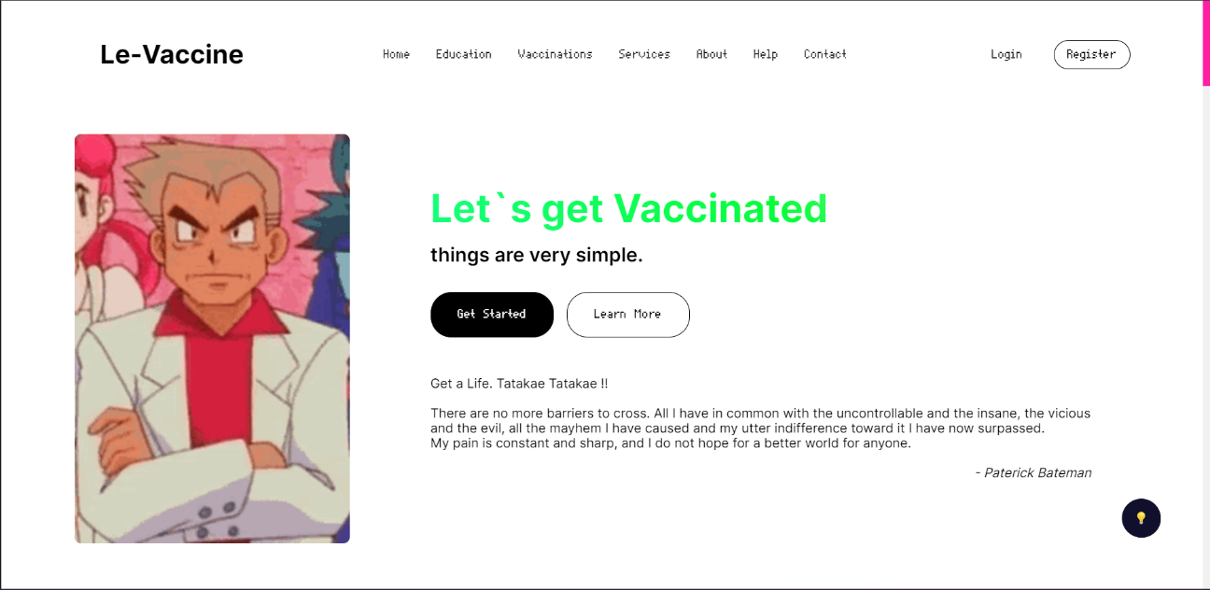

*Figure 6.1*

* Vaccinations:

This page gives the information of the actual vaccination done by using this site which is mapped and an external open API which provide daily records of Covid-19 cases all over the world

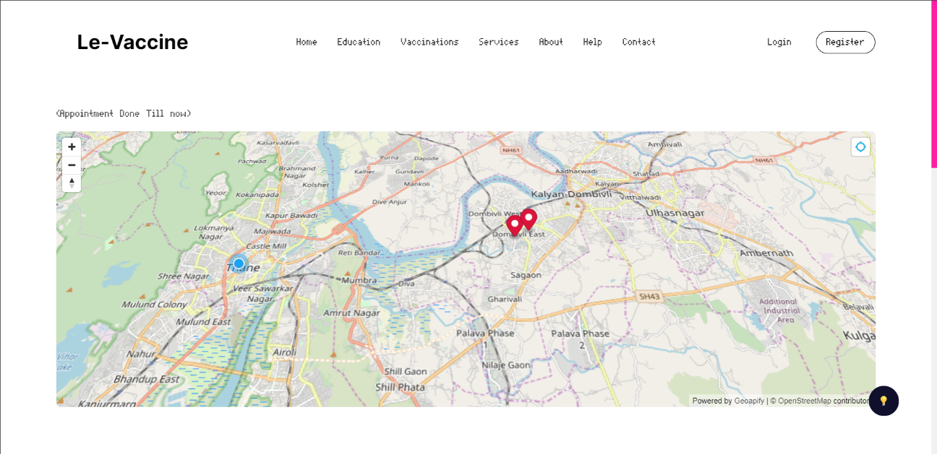



*Figure 6.2*

*Figure 6.3*

* APIs

This page is only for registered users, provider, producer which can use vaccinations data generate by the site for their own use.

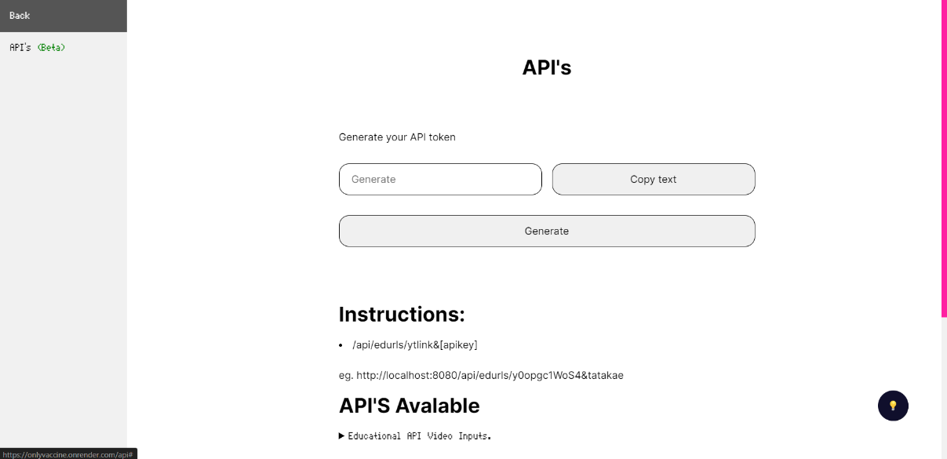

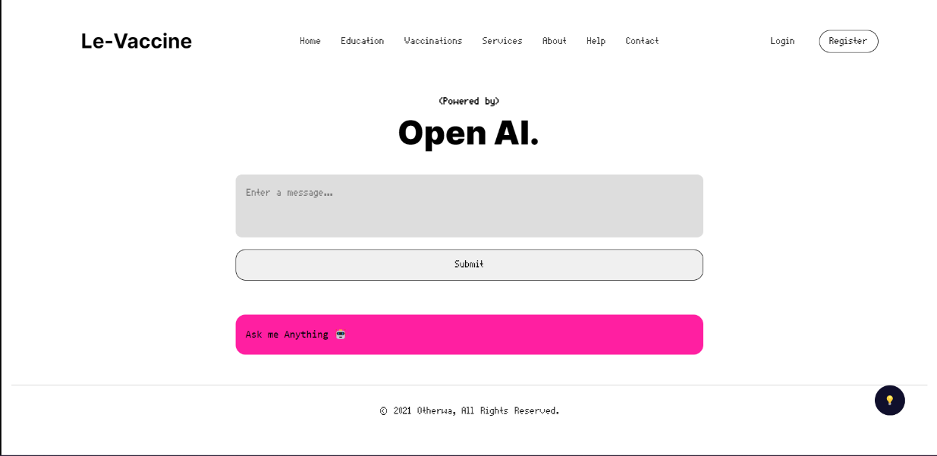

*Figure 6.4*

* Help:

Open AI Chat-bot is also integrated using API services.

*Figure 6.5*

User :

* Login:

The Required User can login through this page this page is a common point for different roles

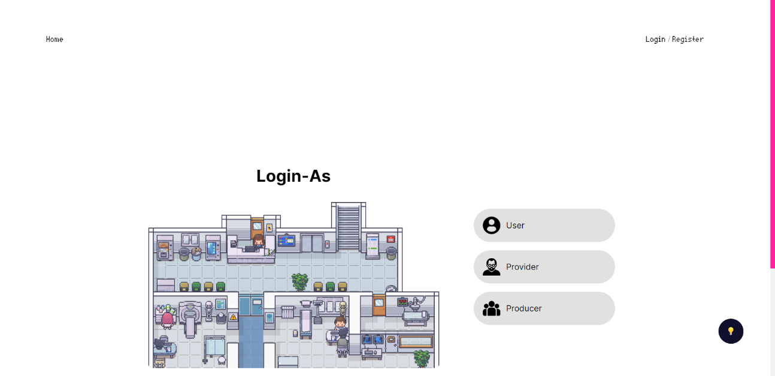

*Figure 6.6*

* Dashboard:

This is the first page the user sees after logging in

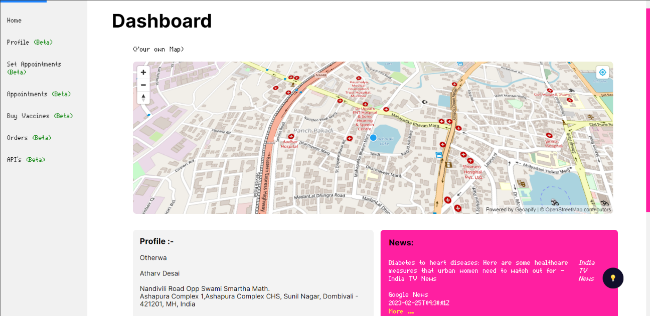

*Figure 6.7*

* Profile:

Here the user can update his/her profile as per the need

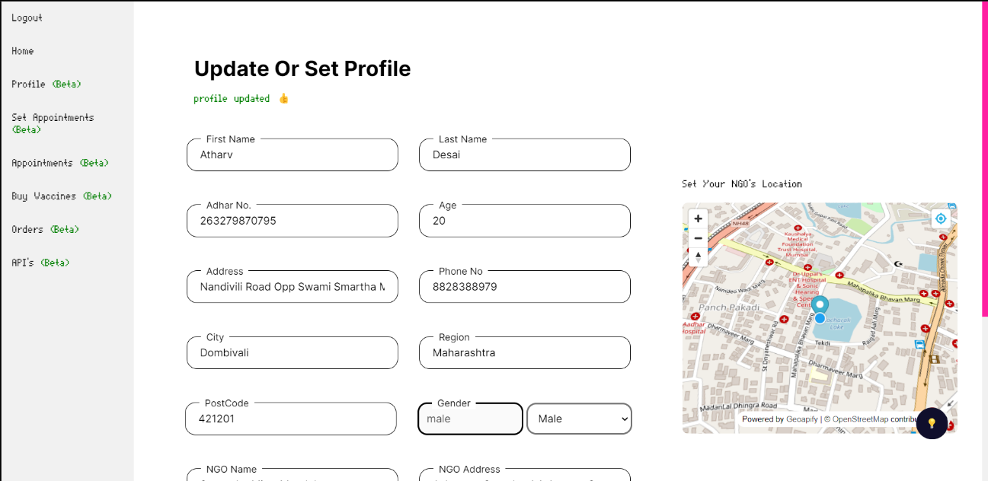

*Figure 6.8*

* Book Appointments:

Here the user can book appointment which is nearby matching his /her by using pincode for lookup

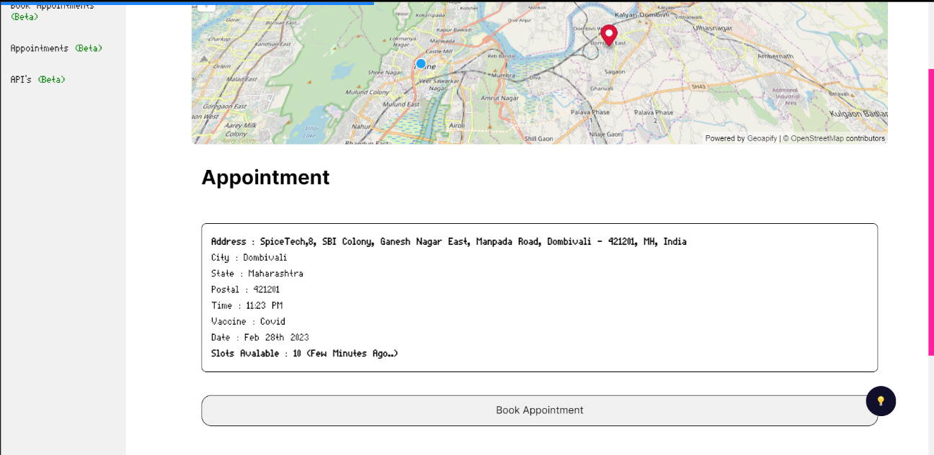

*Figure 6.9*

Provider :

* Login:

 Appropriate Provider can login

*Figure 6.10*

* Dashboard:

 The First page the Provider Sees

*Figure 6.11*

* Profile:

Here the Provider can update his or her NGO profile etc.

*Figure 6.12*



* Set Appointments:

Here The Provider can set Appointments as per the need

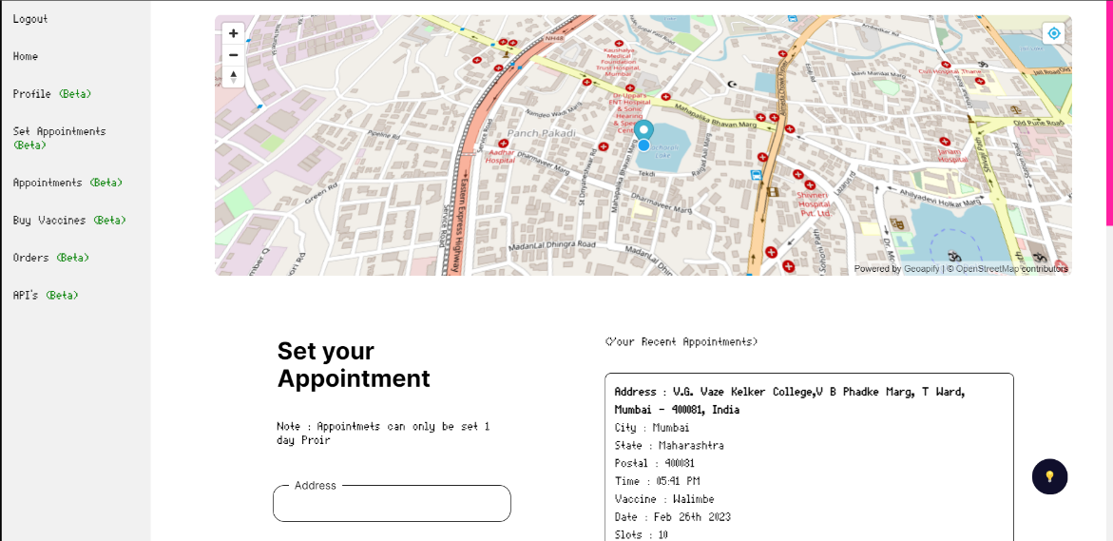

*Figure 6.13*

* Appointments:

Here the Provider can see his/her appointments and can either stop or start for slots

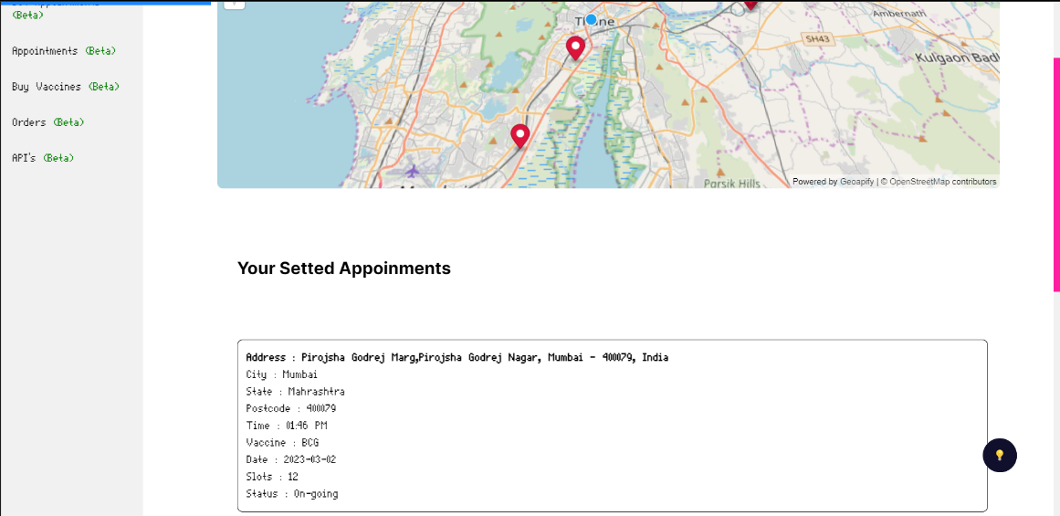

*Figure 6.14*

* Buy Vaccine

Here the Provider can buy Vaccine which are required

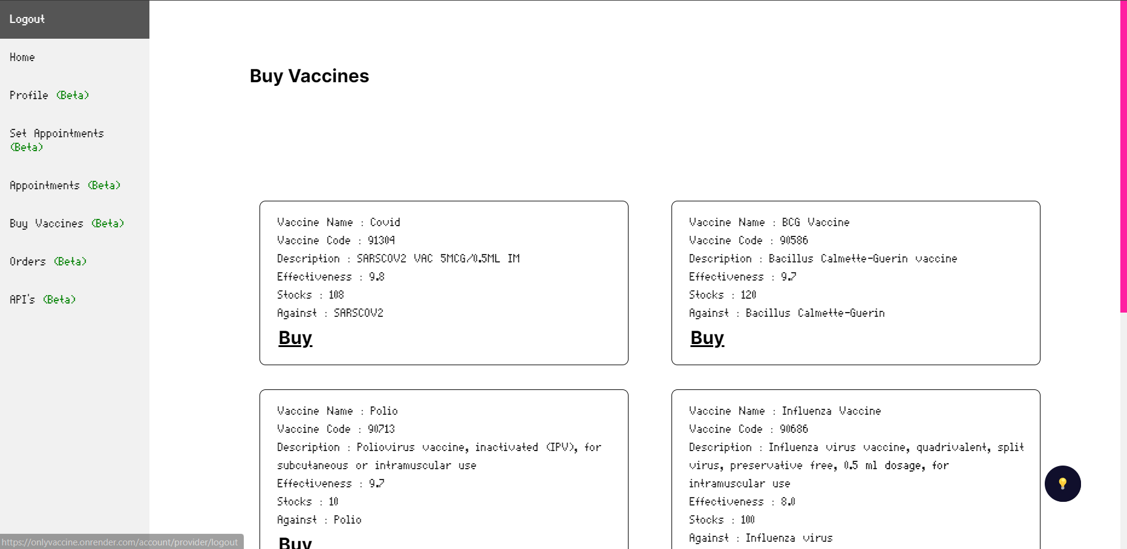

*Figure 6.15*

* Orders:

Here The Provider can keep track of the Vaccine Orders Placed.

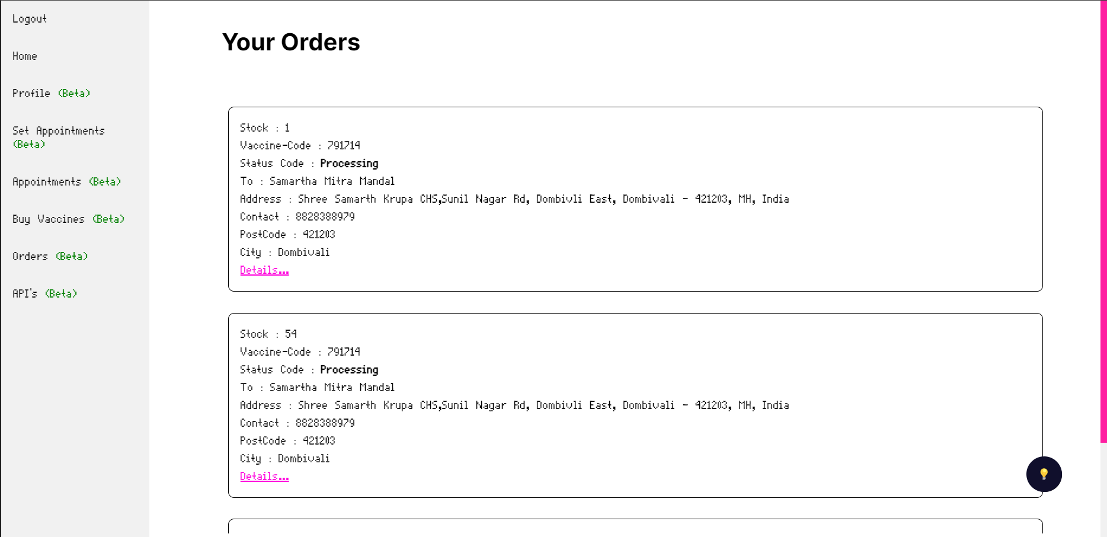

*Figure 6.16*

Producer:

* Login

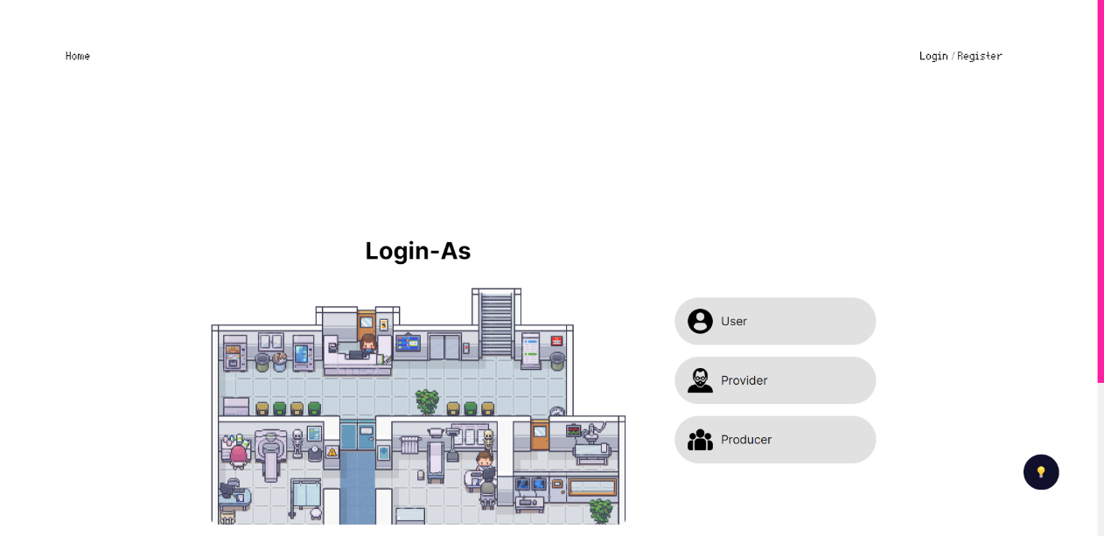 The First Page the Provider Sees For logging in

*Figure 6.17*

* Dashboard

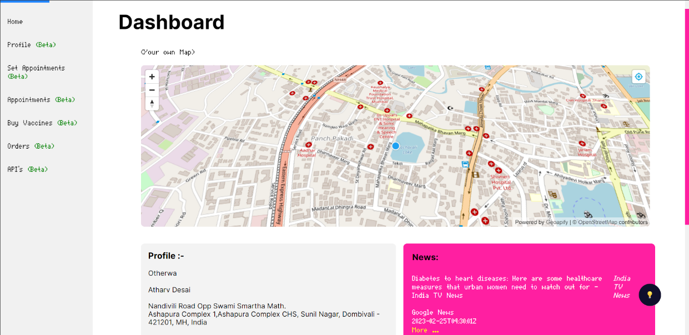

This is the first page the producer sees after logging in

*Figure 6.18*

* Authorize

Here the Producer can Authorize or Unauthorized the Provider of certain NGO

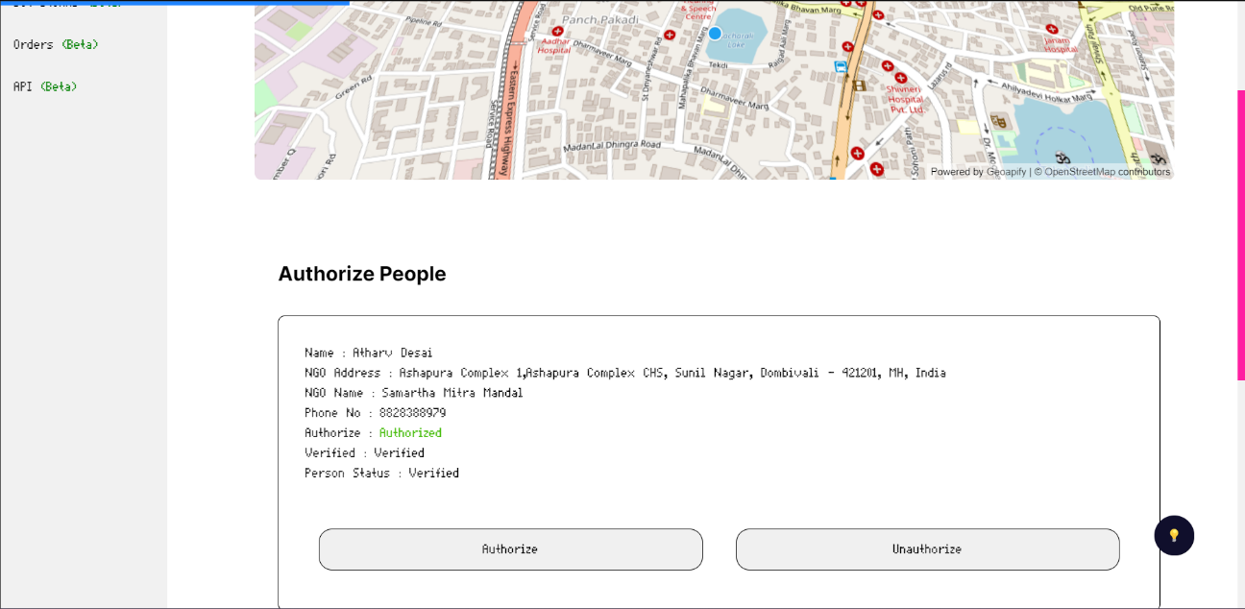

*Figure 6.19*

* Orders

Here the Producer can Process the Orders Received From the Providers



*Figure 6.20*

* Stocks:

 Here the Producer can set stocks for the vaccine they can manufacture

*Figure 6.21*

## 7.1 Conclusion

The most thing I learnt was time management, if we manage our time properly then we can finish anything before the deadline. I also learnt that designing and planning are one of the important things. This project took me through the various phases of project development and gave me real insight into the world of software engineering.

In conclusion, developing a vaccine management system using MongoDB and Node.js for our college project was a great learning experience. Through this project, we were able to gain practical experience in designing and implementing a full-stack application that can be used to manage vaccine distribution and administration.

One of the main benefits of using MongoDB as our database management system was its flexibility and scalability. Unlike traditional relational databases, MongoDB allowed us to easily store and retrieve data in a document-based format, which made it easy to manage and manipulate data in real-time. Additionally, the ability to scale our database horizontally across multiple servers allowed us to handle large amounts of data with ease, which is particularly important for a vaccine management system that requires fast and efficient data processing.

Node.js was also an excellent choice for our project, as it provided us with a fast and efficient platform for building server-side applications. Its event-driven architecture and non-blocking I/O model allowed us to develop a highly responsive and performant application that can handle a large number of requests simultaneously.

Throughout the development process, we faced several challenges, such as designing a user-friendly interface and ensuring data security. However, through collaboration and teamwork, we were able to overcome these challenges and deliver a fully functional application that met our project requirements.

One of the most rewarding aspects of this project was the knowledge and skills we gained from it. We learned about the importance of data management and security, as well as the benefits of using modern technologies such as MongoDB and Node.js. We also learned about the importance of collaboration and communication in a team-based project, which will undoubtedly be beneficial in our future careers.

In summary, our experience in developing a vaccine management system using MongoDB and Node.js was both challenging and rewarding. We gained valuable knowledge and skills, and we are proud of the final product we delivered. We believe that our application has the potential to make a positive impact in managing vaccine distribution and administration, and we hope to see it implemented in the real world.

Furthermore, this project has also given the opportunity to showcase our abilities to potential employers and stand out in a highly competitive job market. By demonstrating our ability to design and develop a functional application, we can confidently apply for positions that require experience in full-stack development, data management, and security. Overall, this project has been an invaluable experience that has prepared us for real-world challenges and opportunities.

In addition, the use of agile development methodologies helped us to streamline our development process, ensure that we were meeting project requirements, and keep track of progress in a timely manner. This allowed us to make necessary adjustments quickly, saving time and resources in the long run. Overall, this project has been a valuable learning experience that we can apply in our future endeavors.

## 7.2 Limitations

* Due to Financial Issues this Project is only Capable for users in Maharashtra.
* This Project is only capable to Handle Moderate Traffic as the hosting solution is based on 1 CPU core and 2GB RAM. (Financial Issue).
* Only has 512 MB of Database Storge Size (Financial Issue).

## 7.3 Future Scope:

* An Android or IOS application can be suitably developed reusing the RESTful APIs developed for the project
* Should be used anywhere in the world

# References

## Websites

* <https://cdsco.gov.in/opencms/export/sites/CDSCO_WEB/Pdf-documents/biologicals/facilitiesLIST.pdf>

as of 19/05/22

* [https://www.who.int/emergencies/diseases/novel-coronavirus-2019/question-and-answers-hub/q-a-detail/coronavirus-disease-(covid-19)-vaccines?adgroupsurvey={adgroupsurvey}](https://www.who.int/emergencies/diseases/novel-coronavirus-2019/question-and-answers-hub/q-a-detail/coronavirus-disease-(covid-19)-vaccines?adgroupsurvey=%7badgroupsurvey%7d)

as of 22/09/22

* <https://www.servicenow.com/solutions/vaccine-management.htm>

as of 01/09/22

* <https://www2.deloitte.com/us/en/pages/public-sector/solutions/vaccine-management-system.htm>

as of 02/06/22

* [https://www.intelex.com/products/applications/vaccine-management}{Intelex Vaccine Solution](https://www.intelex.com/products/applications/vaccine-management%7d%7bIntelex%20Vaccine%20Solution)

as of 05/05/22

* <https://www.zenflowchart.com/guides/data-flow-diagram>

as of 01/09/22

* <https://www.newthinktank.com/2019/01/latex-tutorial/>

as of 28/06/22

* <https://online.visual-paradigm.com/drive/#diagram:proj=0&type=GanttChart&workspace=mhujsaxv&id=2>

as of 12./07/22

* <https://www.lucidchart.com/pages>

as of 16/08/22

* <https://www.mongodb.com/docs/manual/core/data-modeling-introduction/>

as of 15/08/22

* <https://www.lucidchart.com/pages/uml-use-case-diagram>

as of 21/08/22

* <https://www.lucidchart.com/pages/uml-sequence-diagram>

as of 22/08/22

* <https://www.lucidchart.com/pages/data-flow-diagram>

as of 23/08/22

* <https://www.lucidchart.com/pages/uml-state-machine-diagram>

as of 21/08/22

* <https://www.lucidchart.com/pages/uml-activity-diagram>

as of 20/08/22

* <https://youtu.be/WnMQ8HlmeXc>

as of 07/09/22

## Reference books

* Practical MongoDB: Architecting, Developing, and Administering MongoDB

Author : [Shakuntala Gupta Edward](https://www.pdfdrive.com/search?q=Shakuntala+Gupta+Edward) & [Navin Sabharwal](https://www.pdfdrive.com/search?q=Navin+Sabharwal) as of 16/07/22

* Software Engineering 9th Edition

Author : Ian Sommerville as of 19/06/22

* Learning Node.js Development: Learn the fundamentals of Node.js, and deploy and test Node.js applications on the web

Author :  [Andrew Mead](https://www.amazon.in/s/ref=dp_byline_sr_book_1?ie=UTF8&field-author=Andrew+Mead&search-alias=stripbooks)  as of 20/08/22

* Beginning Node.js, Express & MongoDB Development

Author : Greg Lim  as of 22/08/22

* **Fundamentals of Creating a Great UI/UX**

Author: - Creative Tim as of 23/08/22